Mathematical Calculation of a LPF:
R = 1M ohm
C = 1p
f = ½*pi*R*C = 1/ 2*pi*1M*1P = 159.154 KHz

Schematic:
Vsin ac voltage = 1V
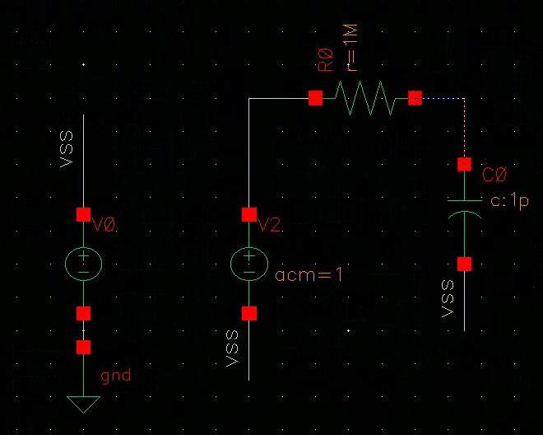
ADE L Window:
AC 1 1G automatic start-stop

Output:
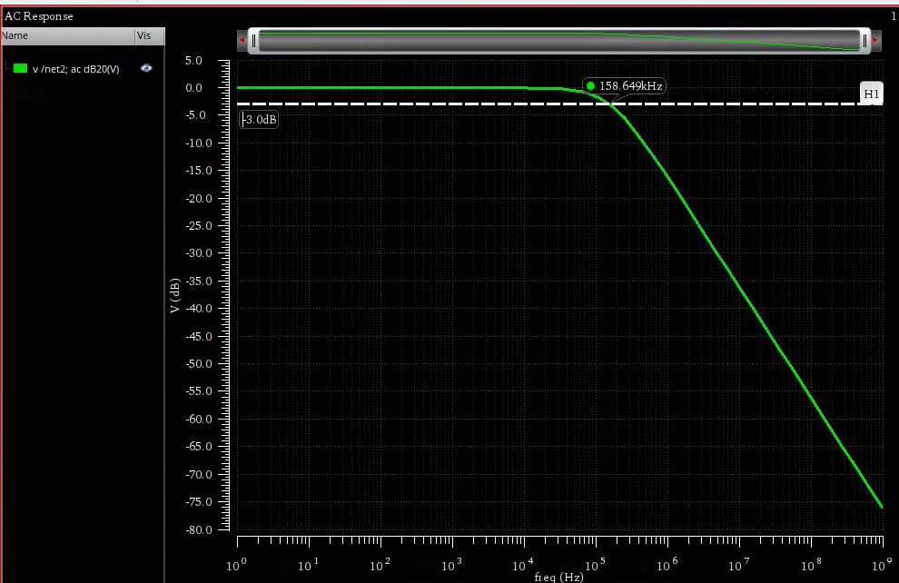

The output closely matches the input. The discrepancy is because the mathematical calculation assumes the ideal system.

Pole Zero Analysis:
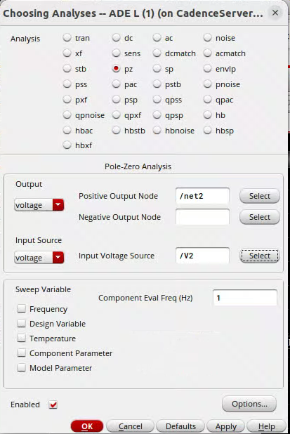
After analysis, go direct plot- main form – select pz


